

PULSE OXIMETER

User Manual

Model:
□A300 □A310 □A320 □A330 □A340
□A310L □A340L

PLEASE NOTE:
THIS MEDICAL INSTRUMENT MUST BE USED ACCORDING TO INSTRUCTIONS TO ENSURE ACCURATE READINGS


File No.: A310 series PO-UM V 2.0 2025-08-05

Table 1: Device diagram of A310 series pulse oximeter
Model | A300 | A310 | A320
Annotated diagram | 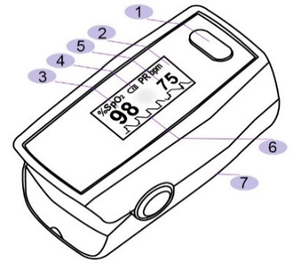 | 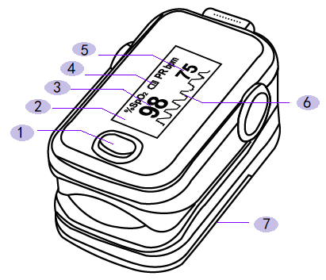 | 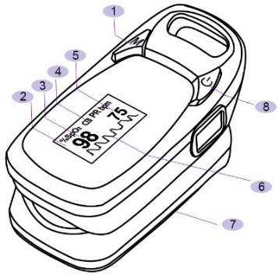
Model | A330 | A340
Annotated diagram | 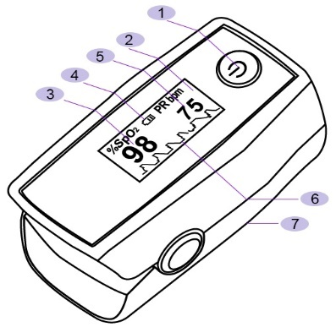 | 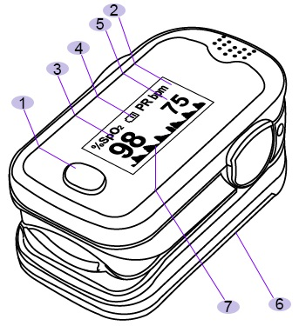
Model | A310L | A340L
Annotated diagram | 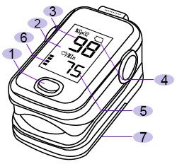 | 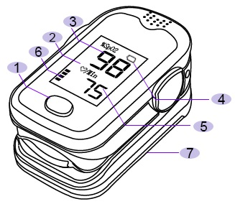


Shenzhen Aeon Technology Co., Ltd.
A301, Building A, Donghua Industrial Park, No. 5003, Bao'an Avenue, Sanwei Community, Hangcheng Street, Bao'an District, 518126 Shenzhen, CHINA.
Tel: +86-755-86182155
Customer Service E-mail: market@aeon-med.com
Website: www.aeon-med.com


Shanghai International Holding Corp. GmbH (Europe)
Eiffestrasse 80, 20537 Hamburg, Germany
Tel: +49-40-2513175 E-mail: shholding@hotmail.com

Content
1 Safety 4
1.1 Instructions for the Safe Operation and Use of the A310 Series Pulse Oximeter 4
1.2 Warning 4
1.2.1 Cautions 6
1.3 Definitions and Symbols 7
2 Introduction 7
2.1 Intended use 7
2.2 Brief Device Description 8
2.3 Product Features 8
2.4 Expected Service Life 9
2.5 Contraindications 9
3 Installation, Setup and Operation 9
3.1 OLED display parameter setting 9
3.1.1 Remind Setup 9
3.1.2 Sound reminder 9
3.1.3 Beep 9
3.1.4 Restore 9
3.1.5 Demo 9
3.1.6 Brightness 10
3.1.7 Limit Value Setting 10
3.2 Operation 10
3.2.1 Installing batteries 10
3.2.2 Turning on and applying the Pulse Oximeter 10
3.2.3 Read data from display screen 10
4 Cleaning and Disinfection 11
4.1 Cleaning 11
4.2 Disinfection 11
5 Troubleshooting and Maintenance 12
5.1 Maintenance 12
5.2 Troubleshooting 12
6 Specification 13
7 Clinical SpO2 Accuracy 13
8 Disposal 14
9 Certificate of guarantee 15
10 Manufacturer’s EMC Declaration 15

Table 2: Description of the number in the product diagram above
No. | Description | No. | Description | No. | Description | No. | Description
 | Power button |  | SpO2 data |  | Pulse Rate data |  | Battery cover
 | Display |  | Battery Indicator |  | Plethysmogram |  | Power off button

Safety

Instructions for the Safe Operation and Use of the A310 Series Pulse Oximeter
- Do not attempt to service the A310 Series Pulse Oximeter. Only qualified service personnel should attempt any needed internal servicing.
- Prolonged use or the patient’s condition may require changing the sensor placement periodically. Change the sensor placement and check sensor is in contact with exposed skin, circulatory status, and correct alignment at least every 2 hours.
- Oxygen saturation (SpO2) measurements may be adversely affected in the presence of high ambient light. The sensor area should be shielded with a surgical towel, plaster, or bandage if necessary.
- The following factors may cause interference to the testing accuracy of the A310 Series Pulse Oximeter:
- High-frequency electrosurgical equipment.
- Placement of the sensor on an extremity with a blood pressure impacted by arterial catheter, or intravascular line.
- If the patient has severe hypotension, vasoconstriction, severe anemia, or hypothermia.
- If the patient is in cardiac arrest or in shock.
- Fingernail polish or false fingernails may cause inaccurate SpO₂ readings.
- The device should be given at least 10 minutes to come to normal working temperature if stored in a hot or cold environment.
- The device is non-sterile and not intended to be sterilized.
- No SpO2 alarm, no pulse rate alarm.
- When signal is inadequate, an unnormalized waveform will be provided.
- When the signal detected by the device is incomplete or weak, SpO2 and pulse rate readings shown in the display are "- -" and "- - -" respectively. After powering up, "Finger out" appears on the display when the device does not detect a signal.

Warning
The MEDICAL ELECTRONIC EQUIPMENT is suitable for home healthcare environments:
- Although the medical electronic equipment conforms to the intent of the standard EN 60601-1-2 in relation to electromagnetic compatibility, electrical equipment may produce interference. If interference is suspected, move the equipment away from the sensitive device.
- Portable and mobile RF communication equipment can affect this instrument’s normal operation.
- Explosion hazard - Do not use the Pulse Oximeter in a flammable atmosphere where concentrations of flammable anesthetics or other materials may occur.
- Do not throw batteries in fire as this may cause them to explode.
- Do not attempt to recharge normal dry-cell batteries, they may leak and may cause a fire or even explode.
- Do not use the Pulse Oximeter in an MRI or CT environment.
- Do not modify this equipment without the authorization of the manufacturer.
- If this equipment is modified, appropriate inspection and testing must be conducted to ensure continued safe use of equipment.
- Do not use near active high frequency surgical equipment and the RF shielded room of an ME system for magnetic resonance imaging, where the intensity of electromagnetic disturbances is high.
- Use of this equipment adjacent to or stacked with other equipment should be avoided, because it could result in improper operation. If such use is necessary, this equipment and the other equipment should be observed to verify that they are operating normally.
- Use of accessories, transducers, and cables other than those specified or provided by the manufacturer of this equipment could result in increased electromagnetic emissions or decreased electromagnetic immunity of this equipment and result in improper operation.
- Portable RF communications equipment (including peripherals such as antenna cables and external antennas) should be used no closer than 30 cm (12 inches) to any part of the A310 Series Pulse Oximeter, including cables specified by the manufacturer. Otherwise, it may result in a degradation of the performance of this equipment.
- High-pressure sterilization cannot be used on the device.
- IF ANY: a list of all cables and maximum lengths of cables (if applicable), transducers and other accessories that are replaceable by the responsible organization and that are likely to affect compliance of the me equipment or me system with the requirements of clause 7 (emissions) and clause 8 (immunity). accessories may be specified either generically (e.g., shielded cable, load impedance) or specifically (e.g., by manufacturer and equipment or type reference).
- IF ANY: the performance of the me equipment or me system that was determined to be essential performance and a description of what the operator can expect if the essential performance is lost or degraded due to em disturbances (the defined term “essential performance” need not be used).
- Use of accessories, transducers and cables other than those specified or provided by the manufacturer of this equipment could result in increased electromagnetic emissions or decreased electromagnetic immunity of this equipment and result in improper operation.”
- Electromagnetic field are capable of interfering with the proper performance of the device. Therefore, make sure that all external devices operated in the vicinity of the device comply with the relevant EMC requirements. Wireless communications equipment such as wireless home network devices, mobile phones, cordless telephones and their base stations, walkie-talkies or MRI devices are a possible source of interference as they may emit higher levels of electromagnetic radiation.
- The user and/or patient should report any serious incident that has occurred in relation to the device to the manufacturer and the competent authority of the Member State in which the user and/or patient is established.

Cautions
- The Pulse Oximeter is intended only as an adjunct in patient assessment. It must be used in conjunction with other methods of assessing clinical signs and symptoms.
- Consult a healthcare professional if SpO₂ falls below 94% or pulse rate exceeds 120 BPM persistently.
- Keep the operating environment free of dust, vibrations, corrosive, or flammable materials, and extremes of temperature and humidity.
- Do not operate the unit, if it is damp or wet because of condensation or spills. Avoid using the equipment immediately after moving it from a cold environment to a warm, humid location.
- Never use sharp or pointed objects to operate the front-panel switches.
- The batteries must be taken out from the battery compartment, if the device will not be used for a long time.
- The device shall only be used with the battery cover closed.
- The batteries must be disposed of properly, according to local regulation after their use.
- Keep the device away from children and pets to avoid swallowing.
- The ME EQUIPMENT or ME SYSTEM is suitable for home healthcare environments and so on.
- Don’t near active HF surgical equipment and the RF shielded room of an ME system for magnetic resonance imaging, where the intensity of EM disturbances is high.
- Use of this equipment adjacent to or stacked with other equipment should be avoided because it could result in improper operation. If such use is necessary, this equipment and the other equipment should be observed to verify that they are operating normally.
- Use of accessories, transducers, and cables other than those specified or provided by the manufacturer of this equipment could result in increased electromagnetic emissions or decreased electromagnetic immunity of this equipment and result in improper operation.”
- Portable RF communications equipment (including peripherals such as antenna cables and external antennas) should be used no closer than 30 cm (12 inches) to any part of the Pulse Oximeter (model name: A300, A310, A330, A340, A320, A310L, A340L), including cables specified by the manufacturer. Otherwise, degradation of the performance of this equipment could result.

Definitions and Symbols
Table 3: Description of symbol
Symbol | Description | Symbol | Description
 | Type BF Equipment |  | Batch code ^{[1]}
 | Indicates the item is a medical device |  | Indicates a carry that contains unique device identifier information
 | Information of manufacturer, including name and address |  | Date of manufacture ^{[2]}
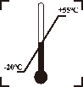 | Temperature limitation |  | Serial No. ^{[3]}
 | For its disposal, this product must be sent to separate collection facilities for recovery and recycling |  | Information of EU authorized representative
 | Follow the instructions for use |  | No SpO₂ Alarms.
Cautions: | The information you should know to protect the equipment from possible damage. | IP22 | Anti-dust & Anti-water class
Note: | The important information you should know. | ME | Medical Electronics Equipment.
Warning: | The information you should know to protect patients and medical staff from possible injury.
Note: [1][2][3] Batch code, Date of manufacture and Serial No. are printed on the label on the battery cover.

Introduction

Intended use
The A310 Series Pulse Oximeter is a non-invasive device intended for spot checking of functional oxygen saturation of arterial hemoglobin (SpO₂) and pulse rate (PR). This portable device is suitable for non-professional adult patients of any color in clinical institutions and home environments.

Brief Device Description
The A310 Series Pulse Oximeter, is based on digital technology. The device is intended for non-invasive spot-check measurement of functional oxygen saturation of arterial hemoglobin (SpO₂). Advanced DSP algorithm ^{[4]} can minimize the influence of motion artifact and improve measurement accuracy of low perfusion ^{[5]}.
The A310 Series Pulse Oximeter can be used to measure human SpO₂ and pulse rate through the finger. The product is suitable for private home-use, hospitals (including clinical use in internist/surgery, anesthesia, pediatrics etc.), social medical organizations, physical care in sports etc.
Note: [4] DSP algorithm: Digital signal processor algorithm.
[5] Low Perfusion: In physiology, perfusion is the process of a body delivering blood to a capillary bed in its biological tissue. Under the condition of low perfusion, the measurement of non-invasive saturation of pulse-blood oxygen is not accurate.

Product Features
- Lightweight for easy carrying and use.
- Manually adjust the direction of interface.
- Color OLED or LED display, simultaneous display for testing value and plethysmography ^{[6]}.
- Visual & Sound reminder function. Real-time spot-checks.
- Low Battery voltage indicator.
- Automatic switch-off.
- Includes two standard AAA 1.5V alkaline batteries.
Note:[6] Plethysmograph: is an instrument for measuring changes in volume within an organ or whole body (usually resulting from fluctuations in the amount of blood or air it contains).

Expected Service Life
The expected service life of the A310 series pulse oximeter is 24 months. Battery not included.

Contraindications
Do not use the device on the persons whose finger is injured.
Do not use the device to continuously monitor patient’s SpO2 and pulse rate.

Intended User
Professional and lay person

Intended patient population
Hypoxemic adults and children of all skin tones.

Intended clinical benefit
Non-invasive, real-time tracking of SpO₂ and pulse rate, rapid identification of low blood oxygen saturation (SpO₂) before clinical symptoms (e.g., cyanosis, confusion) manifest.

Indications
Early Detection of Hypoxemia

Installation, Setup and Operation

OLED display parameter setting
When the device is in the measuring interface, press the direction button for 1 second in order to enter the menu page (figure 3.1.1 and figure 3.1.2). There are two sub-menus.

Remind Setup
Press the direction button for 1 second and enter the Reminder Setup. User can adjust the setting through moving the “*” symbol to the Sound Reminder, Beep, Restore or Brightness.

Sound reminder
Press the direction button for 1 second, move the “*” symbol to the “Sound Reminder”, long press the direction button to turn the alarm sound on/off. If the measured value exceeds the maximum or minimum value of SPO2 or PR, there will be an alarm sound, if this function is turned on.

Beep
Press the direction button for 1 second, move the “*” symbol to the back of “Beep”, long press the direction button to turn the beep sound on/off. When the beep is turned on, the sound emitted during the test indicates the pulse rate.

Restore
With the “*” symbol next to “Restore”, long press the direction button. This will change to “OK”, which restores the device to factory settings.

Demo
With the “*” symbol next to “Demo”, long press the direction button to turn Demo mode on/off.

Brightness
With the “*” symbol next to “Brightness”, long press the direction button to change the Brightness value on a scale from 1 to 5.

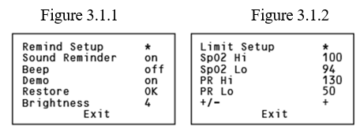
Limit Value Setting
With the “*” symbol next to “Reminder Setup”, long press the direction button until the “Limit Setup” menu appears (figure 3.3.2). You can then press the direction button to select the items. Press the direction button for 1 second to change to the data you need.
On the “Limit Setup” menu page (figure 3.3.2), with the “*” symbol next to “+/-”, press the direction button for 1 second to change the “+” to “-” or change the “-” to “+”.
When “+” shows on the right side, by pressing the direction button for 1 second and moving the “*” next to the Spo2 Hi or PR Hi setting, you can increase the value to a higher value (until it reaches the maximum).
When “-” shows on the right side, by press the direction button for 1 second and moving the “*” next to the Spo2 Lo or PR Lo value setting, you can reduce the value to a lower value (until it reaches the minimum).

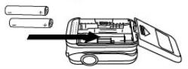
Operation

Installing batteries
Place two AAA batteries into the battery compartment taking care to align the polarities, then close the cover.
WARNING: Do not attempt to recharge normal alkaline batteries, as they may leak and may cause a fire or even explode.

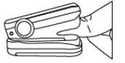
Turning on and applying the Pulse Oximeter
Put one of your fingers into the rubber opening of the A310 Series Pulse Oximeter with nail facing upward, then release the clamp. Press the power button to turn the A310 Series Pulse Oximeter on. The oximeter will automatically turn off, if there is no finger in the device for more than 16±2 seconds.

Read data from display screen
Table 4: Display Description of OLED and LED
Display | Model | Description | Show | Note
OLED Screen | A300, A310, A320, A330, A340 | The screen display can scroll through four directions with six different display modes by pressing the power button. | 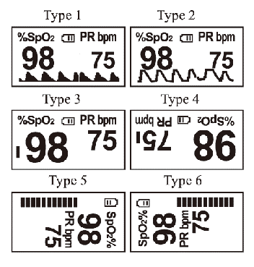 | 1. When the battery power is at its lowest level, the battery symbol will be shown, reminding users to replace the batteries.  2. The plethymogram can been considered accurate if the wave symbol is fluctuating regularly.
LED Screen | A310L, A340L | The display interface of LED only one display modes after pressing the power button. Press the "power" button for 3 seconds to turn on / off the beep sound | 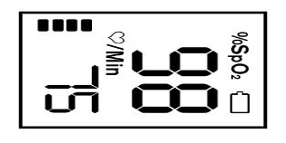 | When battery power is at lowest level, the battery capacity indicates symbol of in LED, remind users of replacement of battery.

Cleaning and Disinfection

Cleaning
Switch off the power and take out the batteries before cleaning. Keep the exterior surface of the device clean and free of dust and dirt. Clean the exterior surface (display screen included) of the unit with a soft dry cloth. Use 75% medical alcohol to clean the surface by applying a small amount with a dry cloth to avoid the alcohol entering the device.

Disinfection
Disinfect the machine after each use, if multiple patients use the machine, e.g., in a hospital.
Use 75% medical alcohol to clean the surface that was in contact with the patient.
CAUTION: Do not use strong solvent, e.g., acetone.
CAUTION: Never use an abrasive such as steel wool or metal polish.
CAUTION: Do not allow any liquid to enter the product and do not immerse any part of the device in liquid.
CAUTION: Avoid pouring liquid on the device while cleaning.
CAUTION: Do not leave cleaning solution on the surface of the device.

Troubleshooting and Maintenance

Maintenance
Replace the batteries in a timely manner, if the battery indication is low. Clean the surface of the oximeter before it is used for diagnosis of patients. Remove the batteries from the battery compartment if the oximeter will not be operated for a long time. It is best to store the product where the ambient temperature is between -25°C and 55°C and humidity is 15% to 93%. Regular inspection is recommended in order to make sure that no obvious damage is present that may affect the safety and performance of the device. Do not expose the device to flammable substances, high or low temperatures or humidity levels outside those in the operation conditions.

Troubleshooting
Table 5: Troubleshooting
Problem | Possible Reason | Resolution
Oxyhemoglobin or heart rate cannot be shown. | 1. Finger is not inserted correctly.  2. Patient’s perfusion is too low to be measured. | 1. Retry by inserting the finger thoroughly.  2. Try a few more times to make sure there is no problem with the product itself. Otherwise seek medical help for exact diagnosis.
Oxyhemoglobin or heart rate is unstable. | 1. Finger might not be inserted correctly.  2. Finger is trembling, or patient's body is moving. | 1. Retry by inserting the finger thoroughly.  2. Try to help the patient keep calm and still.
Oxyhemoglobin or heart rate is outside of the standard range. | 1. Finger might not be inserted correctly.  2. Patient’s SPO2 & PR is abnormal. | 1. Retry by inserting the finger thoroughly.  2. Seek medical help for further examination.
The Oximeter cannot be turned on. | 1. Batteries may need replacement.  2. Batteries might be installed incorrectly.  3. The oximeter might be damaged. | 1. Please replace batteries.  2. Please reinstall the batteries.  3. Please contact your point of purchase.
The screen suddenly turns off. | 1. The device automatically turns off, if there is no signal detected for more than 16 seconds.  2. Batteries may need replacement. | 1. This is a normal process.  2. Replace the batteries.

Specification
Table 6: Specification of A310 series pulse oximeter
Device Name | Pulse Oximeter
Dimensionas (L×W×H) | A310, A310L, A340, A340L: (62*34*31) mm
Dimensionas (L×W×H) | A320: (73*37*38) mm
Dimensionas (L×W×H) | A300, A330: (63*36*34) mm
Weight | Approx.50g - 60g (including 2 × AAA battery)
Anti-electric Shock Type | Internally powered equipment
Anti-electric Shock Equipment Degree | Type BF
EMC Type | Group I Class B
Enclosure Degree of ingress protection | IP22
Internal Power: | 2×AAA 1.5V alkaline batteries
Power Consumption | Below 45mA
Screen | 0.96’ OLED, 0.96’LED
SpO₂ Display | 35-100%
Pulse rate Display | 30-250 BPM
Resolution | SpO2: 1%
Resolution | Pulse rate: 1BPM
Measure Accuracy | SpO2: ±3% (70%-100%); Unspecified (<70%)
Measure Accuracy | PR: ±2BPM or ±2% (root-mean-square difference) of reading, whichever is greater.
Data averaging and other signal processing | 8s
Data Update Period | 1s
Operating Environment | Temperature: +5°C to +40°C  Humidity:15% to 93% non-condensing  Air Pressure: 700hPa-1060hPa
Storage & Transport Environment | Temperature: -25℃ to +55℃  Humidity:15% to 93% non-condensing  Air Pressure: 700hPa-1060hPa
Service life | 24 months
Shelf-life | 5 years
Standard Accessories | 2 generic AAA 1.5V alkaline batteries;  1 detachable lanyard

Clinical SpO2 Accuracy
The below table shows statistic distribution of an invasive controlled desaturation study, which guided by ISO80601-2-61, Annex EE, Guideline for evaluating and documenting SpO2 Accuracy in human subjects.
The statistic distribution displayed the accuracy distribution between the range of 70% ~ 100%, which may helpful to user.
Table 7: Clinical SpO2 Accuracy
Device | Item | 100-70% | 100 - 90% | 90- 80% | 80 - 70%
A310 series | Bs | 1.0 | 0.80 | 1.26 | 0.86
A310 series | Sres | 1.94 | 0.86 | 1.61 | 2.91
A310 series | Arms | 2.18 | 1.17 | 2 | 2.99
The below is the Bland-Altman graphical plot of samples from invasive controlled desaturation study.
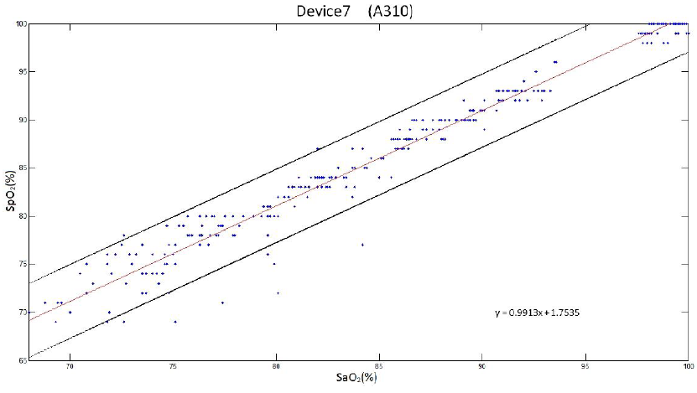
Figure 7.1-Bland & Altman Figure 7.2-Linear regression for SpO2 vs SaO2
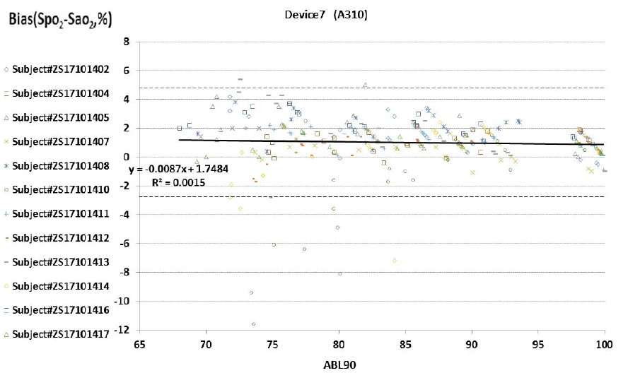

Disposal
Consider the applicable regulations when disposing of the A310 Series Pulse Oximeter and batteries. The pulse oximeter must not be disposed of in the domestic waste. All users are obliged to hand in all electrical or electronic devices, regardless of whether they contain toxic substances, at a municipal or commercial collection point so that they can be disposed of in an environmentally acceptable manner. Please remove the batteries before disposing of the pulse oximeter. Do not dispose of old batteries with your household waste, but at a battery collection station at a recycling site or in a shop.

Certificate of guarantee
Aeon guarantees the A310 Series Pulse Oximeter against any manufacturing defect for one year from the date of purchase, if it is returned to the dealer from which it was purchased in original packaging and with the purchase receipt.
During this period the unit will be repaired or replaced free of charge, if the fault is due to defective design or assembly.
This guarantee does not cover any damage or defect caused by improper handling resulting from use that is not in compliance with these instructions or from unauthorized attempts to repair it.

Format and Accessibility
The user manual is provided in paper format inside the device packaging. Electronic versions are available at www.aeon-med.com

Manufacturer’s EMC Declaration
All necessary instructions for maintaining BASIC SAFETY and ESSENTIAL PERFORMANCE regarding electromagnetic disturbances for the expected service life.
Guidance and manufacturer’s declaration - Electromagnetic Emissions and Immunity.

Table 8 - Guidance and manufacturer’s declaration - electromagnetic emissions
Emissions test | Compliance
RF emissions - CISPR 11 | Group 1
RF emissions - CISPR 11 | Class B
Harmonic emissions - IEC 61000-3-2 | Not application
Voltage fluctuations/ flicker emissions - IEC 61000-3-3 | Not application

Table 9 - Guidance and manufacturer’s declaration - Electromagnetic Immunity
Immunity Test | IEC 60601-1-2 - Test level | Compliance level
Electrostatic discharge (ESD)  IEC 61000-4-2 | ±8 kV contact  ±2 kV, ±4 kV, ±8 kV, ±15 kV air | ±8 kV contact  ±2 kV, ±4 kV, ±8 kV, ±15 kV air
Electrical fast transient/burst  IEC 61000-4-4 | Power supply lines：±2 kV  input/output lines：±1 kV | Not applicable
Surge  IEC 61000-4-5 | line(s) to line(s)：±1 kV.; line(s) to earth：±2 kV.  100 kHz repetition frequency | Not applicable
Voltage dips, short interruptions, and voltage variations on power supply input lines  IEC 61000-4-11 | 0% 0.5 cycle; At 0º, 45º, 90º, 135º, 180º, 225º, 270º and 315º  0% 1 cycle; And 70% 25/30 cycles  Single phase: at 0; 0% 300 cycles | Not applicable
Power frequency magnetic field  IEC 61000-4-8 | 30 A/m  50Hz/60Hz | 30 A/m  50Hz/60Hz
Conduced RF  IEC61000-4-6 | 150KHz to 80MHz: 3Vrms, 6Vrms (in ISM and amateur radio bands); 80% Am at 1kHz | Not applicable
Radiated RF - IEC61000-4-3 | 10 V/m; 80 MHz – 2,7 GHz; 80 % AM at 1 kHz | 10 V/m; 80 MHz – 2,7 GHz; 80 % AM at 1 kHz
Proximity magnetic fields  IEC 61000-4-39 | 30 kHz: 8A/m  134.2 kHz: 65A/m  13.56 MHz: 7.5A/m | 30 kHz: 8A/m  134.2 kHz: 65A/m  13.56 MHz: 7.5A/m
NOTE UT is the a.c. mians voltage prior to application of the test level.

Table 10 - Guidance and manufacturer’s declaration - Electromagnetic Immunity
Radiated RF  IEC61000-4-3  (Test specifications for ENCLOSURE PORT IMMUNITY to RF wireless communications equipment) | Test Frequency  (MHz) | Band  (MHz) | Service | Modulation | Modulation  (W) | Distance  (m) | Immunity test Level (V/m)
 | 385 | 380–390 | TETRA 400 | Pulse Modulation 18 Hz | 1,8 | 0,3 | 27
 | 450 | 430–470 | GMRS 460,  FRS 460 | FM  ±5kHz deviation 1 kHz sine | 2 | 0,3 | 28
 | 710 | 704–787 | LTE Band 13, 17 | Pulse modulation 217 Hz | 0,2 | 0,3 | 9
 | 745
 | 780
 | 810 | 800–960 | GSM 800/900, TETRA 800, iDEN 820, CDMA 850, LTE Band 5 | Pulse modulation  18 Hz | 2 | 0,3 | 28
 | 870
 | 930
 | 1720 | 1700–1990 | GSM 1800; CDMA 1900; GSM 1900; DECT; LTE Band1,3,4, 25; UMTS | Pulse modulation  217 Hz | 2 | 0,3 | 28
 | 1845
 | 1970
 | 2450 | 2400–2570 | Bluetooth, WLAN, 802.11 b/g/n, RFID 2450, LTE Band 7 | Pulse modulation  217 Hz | 2 | 0,3 | 28
 | 5240 | 5100–5800 | WLAN 802.11  a/n | Pulse modulation  217 Hz | 0,2 | 0,3 | 9
 | 5500
 | 5785

Table 11 - Guidance and manufacturer’s declaration - electromagnetic Immunity
Test frequency | Modulation | IMMUNITY TEST LEVEL (A/m)
30 kHz | CW | 8
134,2 kHz | Pulse modulation ª  2,1 kHz | 65 ^{b}
13,56 MHz | Pulse modulation ª  50 kHz | 7,5 ^{b}
a) The carrier shall be modulated using a 50% duty cycle square wave signal.
b) r.m.s., before modulation is applied.

