

Nebulizer Kit

User Manual

Model:
□ A-DA01

PLEASE NOTE:
THE MEDICAL DEVICE MUST BE USED ACCORDING TO USER MANUAL.

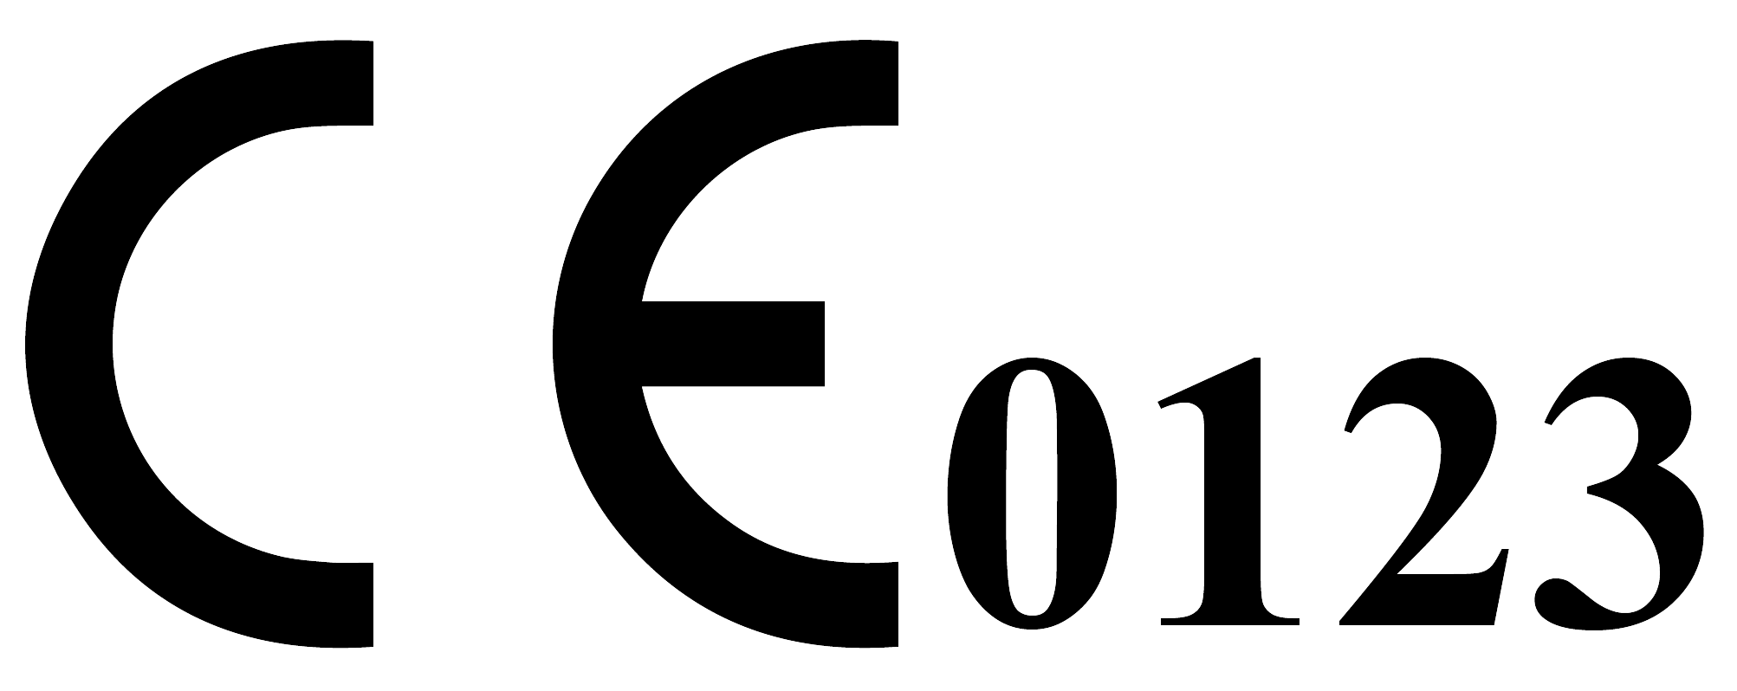

File No.: A-DA01 NK-UM V 1.4 2026-02-05
Content
1 Safety 3
1.1 Important Safety Instruction Read before Use 3
1.2 Caution and Warning 3
1.3 Definitions and Symbols 5
2 Introduction 6
2.1 Intended Use 6
2.2 Indications 6
2.3 Contraindications 7
2.4 Intended User 7
2.5 Intended patients 7
2.6 Intended clinical benefit 7
3 Operating the Nebulizer Kit 7
4 Cleaning 8
5 Troubleshooting 9
6 Specifications 9
7 Compatible devices used in combination 12
8 Warranty 12
9 Disposal of device 13

Information of Manufacturer and Authorized representative in the European Union
Company logo:

Shenzhen Aeon Technology Co., Ltd.
A301, Building A, Donghua Industrial Park, No. 5003, Bao'an Avenue, Sanwei Community, Hangcheng Street, Bao'an District, 518126 Shenzhen, CHINA.
Tel: +86-755-86182155
Customer Service E-mail: market@aeon-med.com
Website: www.aeon-med.com


Shanghai International Holding Corp GmbH (Europe)
Eiffestrasse 80, 20537 Hamburg, Germany.
Tel.: +49-40-2513175
E-mail: shholding@hotmail.com

Table 1: Diagram of nebulizer kit
Nebulizer Kit Diagram | 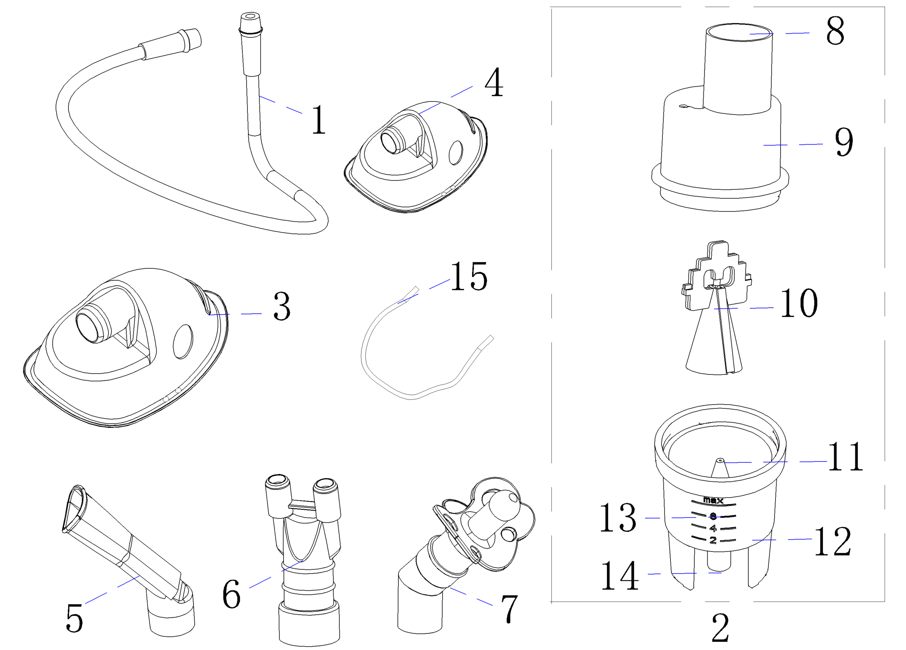
Table 2: Description of the number in the product diagram above
No. | Description | No. | Description | No. | Description
1 | Tube | 2 | Nebulizer | 3 | Adult mask
4 | Child mask | 5 | Mouthpiece | 6 | Nasal inhaler
7 | Pacifier inhaler component | 8 | Aerosol Outlet | 9 | Inhalation Top
10 | Vaporizer Head | 11 | Nozzle | 12 | Medication Cup
13 | Medication Solution Graduated Scale | 14 | Tube Connector | 15 | Head strap for Mask
Note: Model A-DA01 Nebulizer Kit is manufactured by Shenzhen Aeon Technology Co., Ltd.

Safety

Important Safety Instruction Read before Use
The following basic safety precautions should always be taken.
- Close supervision is necessary when the product is used by, on, or near children, handicapped persons or invalids.
- Use the product only for the intended use described in this manual.
- Do not use the product if it is not working properly, or if it has suffered any damage.

Caution and Warning
- Read all instructions carefully before use. And follow the method specified in the manual. The following basic precautions are needed when using an electrical product.
- If the product fails, please refer to this manual. If the failure cannot be eliminated, please contact an authorized service center for repair.
- Connect in order, otherwise the nebulizer effect will be affected.
- Do not use if package is open or damaged, or the product is cracked.
- Keep the product and packaging out of children’s reach to avoid suffocation risk.
- Do not store at extreme temperature, high humidity, or in direct sunlight. Store in a dry, cool place.
- If you have diabetes or other diseases, please consult the corresponding doctor before using the product.
- Be careful with tube, which is prone to strangulation.
- Do not reuse this disposable device. Reuse may cause allergic reactions.
- Max temperature of liquid in the Nebulizer kit ≤ 40℃.
- Before starting treatment, please consult your doctor about the duration of use, dosage of medication, frequency of treatment, etc.
- Ensure that all connections are secure and air circulates freely through the tubing.
- If there are contusions, burns, inflammations, wounds or sensitive parts, please consult the corresponding doctor before using the product.
- In the process of using the product, if you feel unwell, please stop using it immediately and consult the corresponding doctor.
- Please remove all packaging materials before use, and confirm that the parts and accessories of the product are complete.
- If there is no liquid drug in the nebulizer, do not operate the equipment.
- When using, keep the nebulizer as vertical as possible. A slight swing will not affect the use. Please do not move the unit during use.
- The nebulizer kit is compatible only with the compressor nebulizer by Shenzhen Aeon Technology Co., Ltd.
- Do not reuse this disposable device. Reuse may cause cross-infection or the transmission of harmful substances.
- Please consult the corresponding doctor before using any medicinal products or drugs to ensure that they select the appropriate medicinal products for you.
- It is not suitable for viscous drugs, volatile oils and oily drugs, as this may cause damage to the nebulizer.
- Nebulized drugs do not contain bacteriostatic agents and cannot be stored in the nebulizer for a long time, they need to be used immediately after opening. The dosage of each nebulization should be recommended by the doctor, the volume is too large to cause too long nebulization time affecting the compliance of children and other users.
- If your physician prescribes more than one drugs at the same time, please pay attention to whether different drugs can be mixed.
- Avoid excessive eating 30 min before nebulization treatment, and do not apply oily creams before the use of hormonal drugs.
- Children should be nebulized in a quiet state, the best choice of sitting position, for those who cannot take the sitting position, the head should be elevated and 30° with the chest, and young children can be semi-sitting position.
- Clean the face in time after nebulization to remove the drugs attached to the face. Immediately gargle with water for 3 times or more, and spit out the gargle. For child who cannot gargle, use a cotton swab to wipe the mouth for care.

Definitions and Symbols
Table 3: Symbol and Description
Symbol | Description | Symbol | Description
 | Indicates the item isa medical device |  | Indicates a carry that contains unique device identifier information
 | Indicates the manufacturer's serial number so that a specific medical device can be identified |  | Indicates the date after which the medical device is not to be used
 | Indicates the medical device manufacturer |  | Indicates the date when the medical device was manufactured
 | Indicates a medical device that is intended for one single use only |  | Follow the instructions for use
 | Notified Body with identification no. |  | Indicates the authorized representative in the European Community/European Union
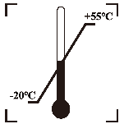 | Indicates the temperature limits to which the medical device can be safely exposed | 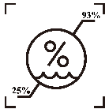 | Indicates the range of humidity to which the medical device can be safely exposed
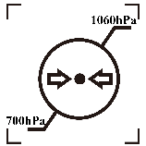 | Indicates the range of atmospheric pressure to which the medical device can be safely ex-posed |  | Upward
 | Indicates that caution is necessary when operating the device or control close to where the symbol is placed, or that the current situation needs operator awareness or operator action in order to avoid undesirable consequences | 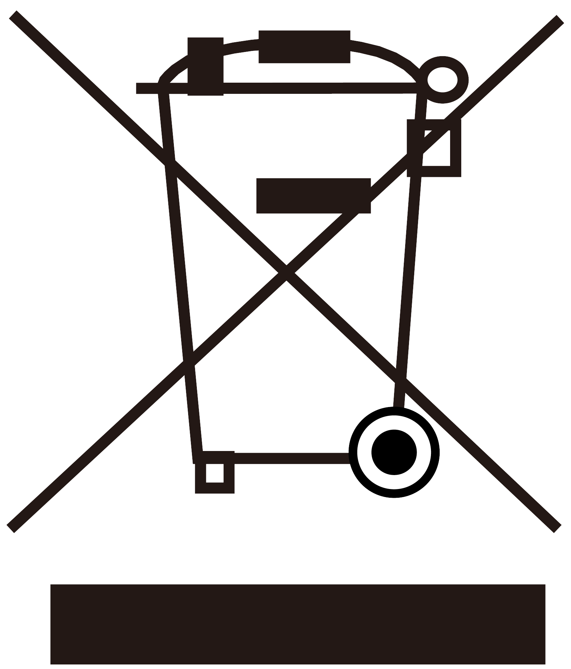 | Symbol for When the end-user wishes to discard this product, it must be sent to separate collection facilities for recovery and recycling
Note | The important information you should know.

Introduction
The nebulizer kit is a small volume jet nebulizer designed to deliver aerosolized medications for inhalation to the respiratory system, the compressed air is forced into the nebulizer through a nozzle cover, where it accelerates and emerges at a high velocity, creating a vacuum (Venturi effect), in the process the liquid drug is converted into small droplets called aerosol by impacting upon a rigid baffle, the aerosol may be used for inhalation treatment of a physician's prescription. The excited drug forms an aerosol that passes through the mouthpiece or mask and can be inhaled by the patient. Its use is indicated whenever a physician or healthcare professional administers or prescribes medical aerosol products to a patient using a Small Volume Nebulizer. Nebulizer kit includes Tube, Nebulizer, Adult Mask, Child Mask, Mouthpiece, Nasal Inhaler, Pacifier Inhaler Component. We encourage you to thoroughly read this guidebook to learn about the features of this product. Any use of this product other than its intended use should always be avoided.

Intended Use
The nebulizer kit is intended to cooperate with compressor to aerosolize physician-prescribed medication for inhalation. It is designed for use with adult and pediatric (≥28 days) patients in hospital, clinic, or home environments.

Indications
Cystic fibrosis, chronic obstructive pulmonary disease (COPD), pneumonia and respiratory infection

Contraindications
- Do not use for patients who are unconscious or are not breathing spontaneously.
- Do not use for patients with acute pulmonary edema.
- Do not use for patients who have completely lost the ability to spontaneously expectorate.
- Premature neonate and newborns.
- Pregnant or breastfeeding women.
- Patient is allergic to aerosolized drugs.

Intended User
Professional and lay person (under the guidance of professional)

Intended patients
Adult, pediatric (≥28 days)

Intended clinical benefit
Indirect: Used in combination with compressor to aerosolize medications.

Operating the Nebulizer Kit

Illustrations | Steps
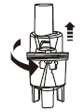 | 1. Gently twist the top part of the nebulizer counter-clockwise and gently lift it to separate the Inhalation Top and Medication Cup of the nebulizer
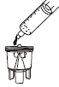 | 2. Fill the bottom section of the nebulizer with the medication prescribed by your physician. Be sure that the small Vaporizer Head are correctly placed in the Medication Cup. Do not exceed the maximum fill volume (see Specifications).
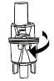 | 3. Gently twist the top part clockwise to re-assemble the nebulizer. Be sure the two sections fit well.
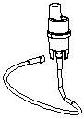 | 4. Attach the air tube.  Attach one end of tube to the base of the nebulizer. Attach the other end of tube to the tube connector located on the front of the compressor.
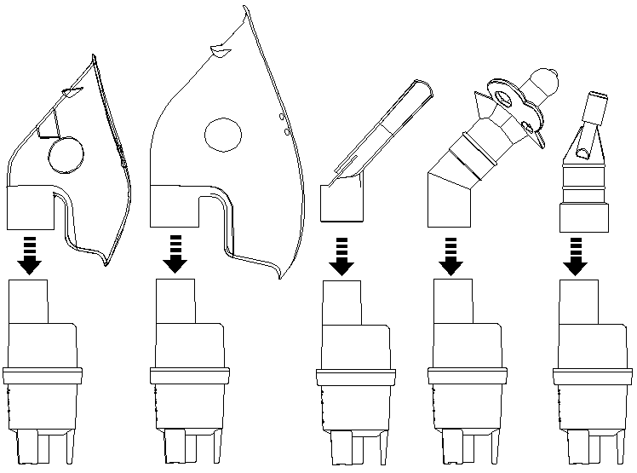  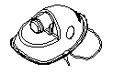 | 5.Attach the mask, mouthpiece, Nasal Inhaler or Pacifier Inhaler Component per your choice to the top section of nebulizer.  - If using a mask (Adult or Child), thread each end of the head strap through the slots on the corresponding sides of the mask. After the strap is pulled through, re-insert the free end back through the adjacent slot to secure it firmly, as illustrated, ensure the head strap is installed securely and comfortably around the user's head.  - If using the Pacifier Inhaler Component, place the silicone part in the mouth with the aerosol output hole aligned towards the nostrils.  - If using the Nasal Inhaler, gently insert the two silicone tips into the nostrils, ensuring the flange rests comfortably against the outside of the nose. Do not insert too deeply into the nasal passages.
This step has no illustration | 6. Turn on the compressor.  7. Check if aerosol is generated from the top of the nebulizer.
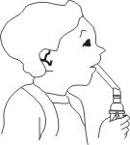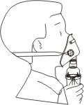 | 8. Keep the nebulizer upright to avoid spillage and ensure complete nebulization of the drug, now you can breathe slowly and deeply, if you hold your breath for a short time after inhaling the drug, you can increase the effect of the treatment.  During the treatment, keep quiet and relax, do not inhale too fast.  If you need to stop for a short time, you can take the Mouthpiece, Mask, Nasal Inhaler or Pacifier Inhaler Component out of your mouth/remove the mask, and put on it to continue inhaling after resting.
This step has no illustration | 9. A single treatment should not take more than 30 minutes.  10. If there is a very small amount of drug left in the nebulizer, stop inhaling.  11. End of treatment. Pour out the remaining drug and don't use it again.  12. Dispose of used nebulizer kit in the trash.

Cleaning
The nebulizer kit is disposable, single-patient-use, intended for single use only. Discard when finished. Do not clean or reprocess.

Troubleshooting
The nebulizer kit should be used by following the operation steps in the manual or using under the guidance of a doctor. Some common problems, faults and troubleshooting methods during the use of the equipment are shown in the following table:
Table 4: Troubleshooting
No. | Problems | Cause Analysis | Elimination method
1 | No fog | 1. The way the device is held is incorrect  2. The nebulizer is not installed  3. The drug is not suitable | 1. Reinstall the nebulizer and its components and ensure it is held upright.  2. Too little drug or not suitable for using the device (please consult your doctor for what drug to use).  3. The way the device is held is incorrect.  4. Please contact authorized repair center or manufacturer.
2 | Foggy | 1. Abrasion of the vertebral body of the nebulizer  2. The drug is not suitable | 1. Replace the nebulizer  2. Too little drug or not suitable for using the device (please consult your doctor for what drug to use)  3. Please contact an authorized repair center or manufacturer
3 | Which drugs are suitable for nebulization | Consult a doctor | It is recommended to use medication under the guidance of a doctor
Notice: Any serious incident that has occurred in relation to the device should be reported to the manufacturer and the competent authority of the Member State in which the user and/or patient is established.

Specifications
Table 5: Nebulizer kit specification
Nebulizer | Maximum fill volume: 8mL
Nebulizer | Dimensions: Outer Diameter Ø 36.0 mm ± 0.08 mm, Height 83.80 mm ± 0.08 mm
Nebulizer | Impact orifice diameter: Inner diameter Ø 0.45mm ± 0.02mm
Nebulizer | Impact distance: 0.5mm ± 0.02mm
Tube | Length: 1000 mm ± 10 mm
Tube | Inner Diameter: Ø 5.0 mm ± 0.08 mm
Mouthpiece | Connector Inner Diameter: Ø 17.00 mm ± 0.08 mm
Mouthpiece | Length: 79.12 mm ± 0.08 mm
Mouthpiece | Width at Patient Contact End: 30.60 mm ± 0.08 mm
Adult mask | Connector Inner Diameter: Ø 17.00 mm ± 0.08 mm
Adult mask | Height: 125.00 mm ± 0.10 mm
Child mask | Connector Inner Diameter: Ø 17.00 mm ± 0.08 mm
Child mask | Height: 96.21 mm ± 0.10 mm
Pacifier inhaler component | Connector Inner Diameter: Ø 17.00 mm ± 0.08 mm
Pacifier inhaler component | Height: 72.49 mm ± 0.08 mm
Nasal inhaler | Connector Inner Diameter: Ø 17.00 mm ± 0.08 mm
Nasal inhaler | Height: 63.85 mm ± 0.08 mm
Head strap for Mask | Length: 430 mm ± 20 mm
Leakage | Positive Pressure Gas Leakage: Under a pressure of (300 ± 10) kPa maintained for 30 seconds, the reservoir connector shall show no leakage sufficient to form a drop of water.
Connection Strength | The connection of compressor nebulizer-tube | No separation when less than 35 N axial disconnection force is applied for 15 seconds
Connection Strength | The connection of tube-tube connector | No separation when less than 35 N axial disconnection force is applied for 15 seconds
Connection Strength | The connection of inhalation top-medication cup | No separation when less than 35 N axial disconnection force is applied for 15 seconds
Connection Strength | The connection between the aerosol outlet and the interface (mouthpiece, adult mask, child mask, nasal inhaler or pacifier inhaler component) of the nebulizer kit | No separation when less than 35 N axial disconnection force is applied for 15 seconds
Connection Strength | The connection between the nebulizer air inlet and the tube | Under a pressure of 300 kPa, the connection between the components should not break and fall off.
Aerosol Output Range and Accuracy | Range: ≥ 3.0 L/min
Aerosol Output Range and Accuracy | Accuracy: ±10% of the value shown
Aerosol Output Rate | 0.2 mL/min – 0.4 mL/min
Residual Volume | ≤ 0.8mL
Mass median aerodynamic diameter (MMAD) | 2.01μm~4.89μm
Maximum Noise | Around 60 dB(A)
Max Temperature of Liquid in The Nebulizer | ≤ 40℃
Applied Parts | Adult Mask, Child Mask, Mouthpiece or Nasal Inhaler, Pacifier Inhaler Component as BF type Applied Parts
Service Life | Disposable, single-patient-use.
Shelf Life | 2 years
Operating Environment | Temperature: +5℃ to +40℃ (+41℉ to +104℉)
Operating Environment | Humidity: 25% to 93% RH (non-condensing)
Operating Environment | Air Pressure: 700hPa-1060hPa
Transport and Storage Environment | Temperature: -20℃ to +55℃ (-4℉ to +131℉)
Transport and Storage Environment | Humidity: 25% to 93% RH (non-condensing)
Transport and Storage Environment | Air Pressure: 700hPa-1060hPa
Set | Standard set:  Tube, Nebulizer, Adult Mask, Child Mask, Mouthpiece
Set | Optional set:  Nasal Inhaler, Pacifier Inhaler Component
Particle Characterization per Cascade Impactor using Albuterol Sulfate for particle size:
AEON nebulizer kit independently measured by Piper Medical, Inc, California, according to ISO 27427 Annex C and D, using albuterol sulfate, ipratropium bromide, and cromolyn sodium. It may vary with the type of medication.
Notes:
- Subject to technical modification without prior notice.
- The AEON compressor nebulizer is produced under the strict quality system of Shenzhen Aeon technology Co., Ltd., China.
- The device may not work if the temperature and voltage conditions are different to those defined in the specifications.
- The AEON nebulizer kit fulfils the provisions of the European Standard ISO 27427: Anaesthetic and respiratory equipment - Nebulizing systems and components.
- Performance may vary with drugs such as suspensions or high viscosity. See drug supplier's data sheet for further details.
- Please contact your dealer for assistance with any other difficulties.

Compatible devices used in combination
Device name | Model | Specification | Manufacturer
Compressor Nebulizer | A500LWD01  A500LWDC01 | Aerosol Output Range and Accuracy: Range: ≥ 3.0 L/min, accuracy: ±10% of the value shown;  Aerosol Output Rate: 0.2 mL/min – 0.4 mL/min | Shenzhen Aeon Technology Co., Ltd.
Compressor Nebulizer | A500LWD02  A500LWDC02 | Aerosol Output Range and Accuracy: Range: ≥ 3.0 L/min, accuracy: ±10% of the value shown;  Aerosol Output Rate: 0.2 mL/min – 0.4 mL/min | Shenzhen Aeon Technology Co., Ltd.
Compressor Nebulizer | A500LWD04  A500LWDC04 | Aerosol Output Range and Accuracy: Range: ≥ 3.0 L/min, accuracy: ±10% of the value shown;  Aerosol Output Rate: 0.2 mL/min – 0.4 mL/min | Shenzhen Aeon Technology Co., Ltd.
Compressor Nebulizer | A500LWD05  A500LWDC05 | Aerosol Output Range and Accuracy: Range: ≥ 3.0 L/min, accuracy: ±10% of the value shown;  Aerosol Output Rate: 0.2 mL/min – 0.4 mL/min | Shenzhen Aeon Technology Co., Ltd.

Warranty
Before open the package, please check to ensure all components are complete. This nebulizer kit is for single use only. The warranty period of the nebulizer kit is 6 months from the date of sale (see the package for manufacturing date). We will not provide free warranty service for the failure caused by the user's reasons as follows:
- Any damage caused by improper use, reuse, failure to operate in accordance with the requirements or transfer of the nebulizer kit to other users.
- Failure caused by dropping during use or handling.
- Failure to operate in accordance with the correct instructions in the user manual.
Repair service beyond warranty will be charged accordingly. After-sale service unit: Shenzhen Aeon Technology Co., Ltd.

Disposal of device
Adhere to the applicable regulations when disposing of Nebulizer Kit. This device must not be disposed of together with domestic waste. The nebulizer kit should be processed according to the local law and regulations at the stage of its life expectancy.

